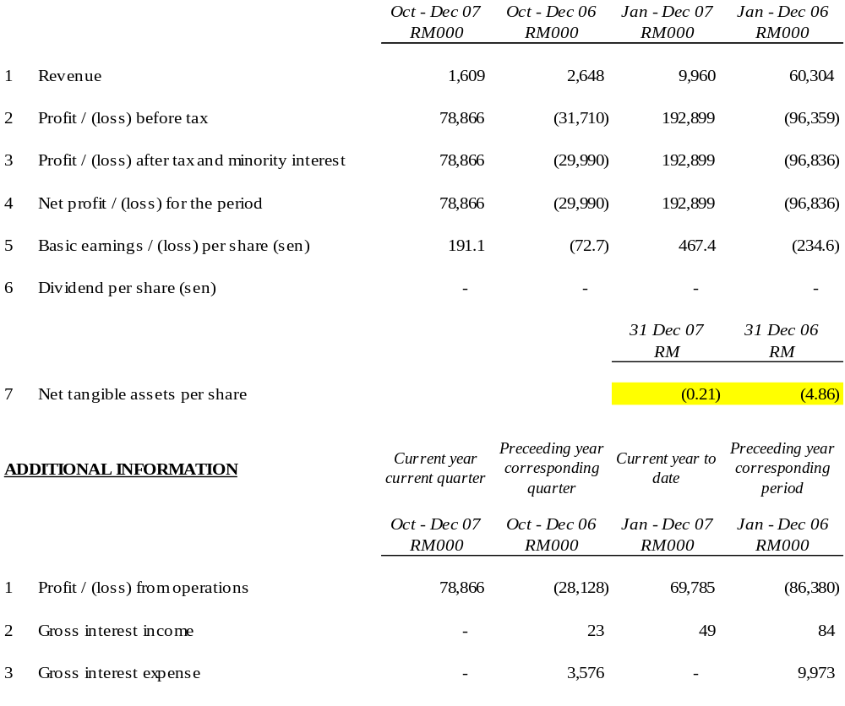

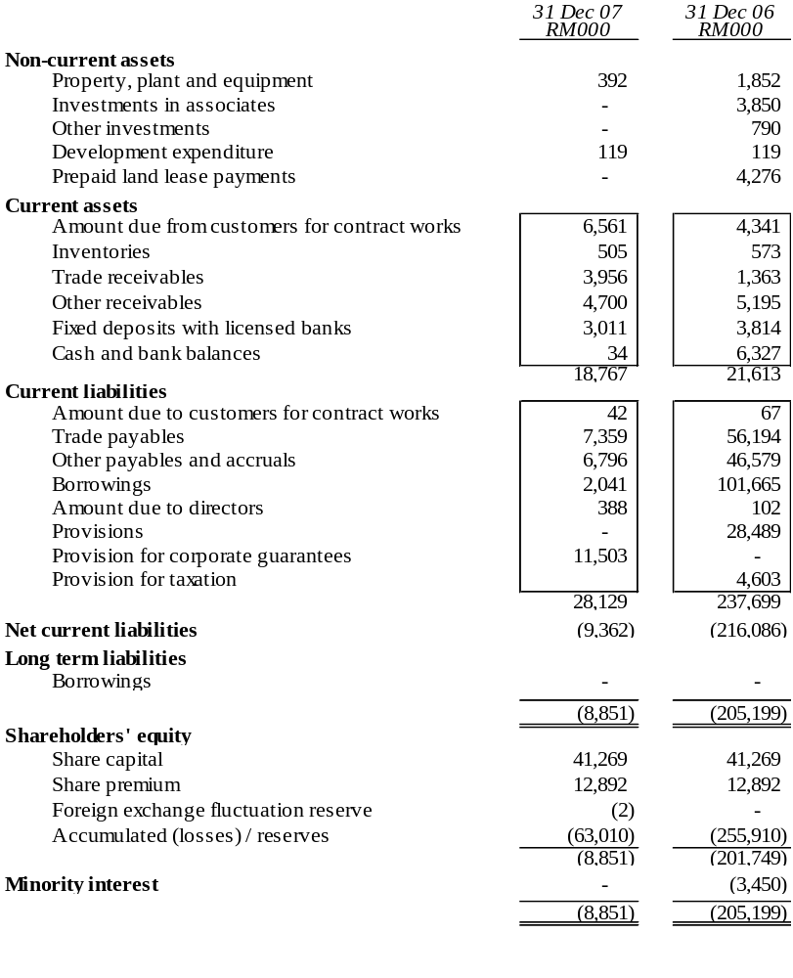

The condensed consolidated balance sheet should be read in conjunction with the Annual Financial Report for the year ended 31 December 2006.

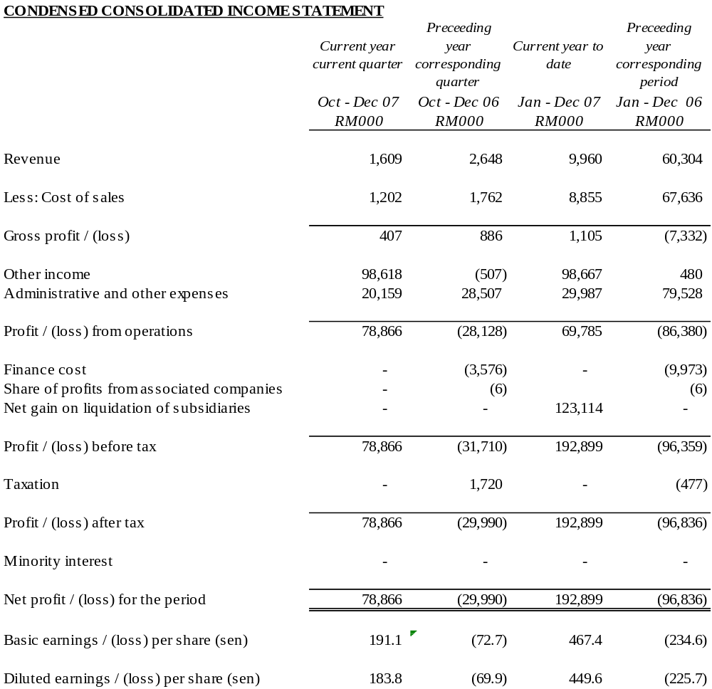

The condensed consolidated income statement should be read in conjunction with the Annual Financial Report for the year ended 31 December 2006.

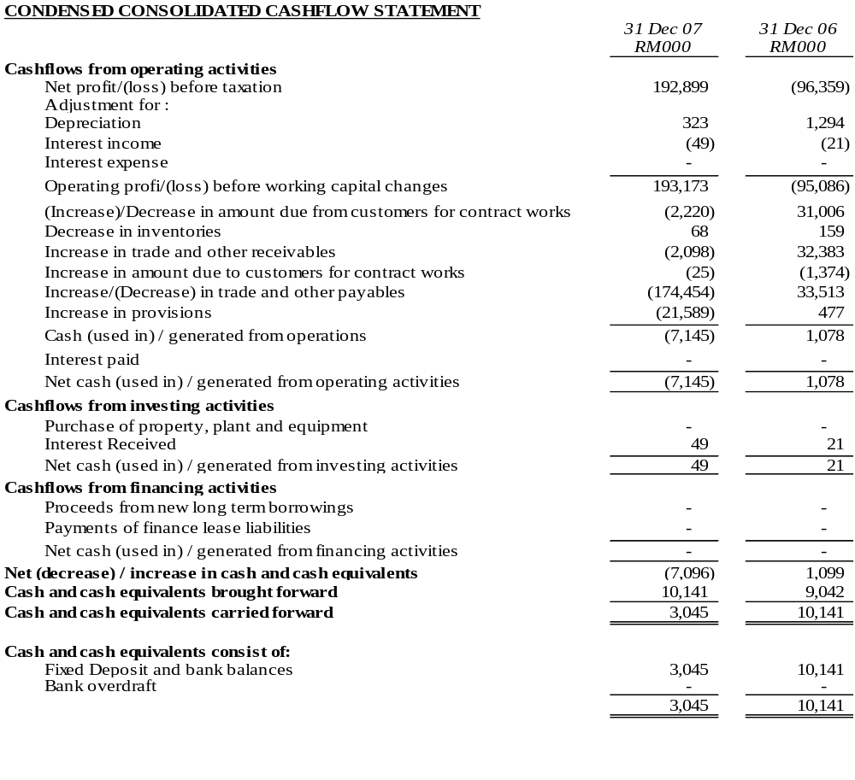

The condensed consolidated cashflow statement should be read in conjunction with the Annual Financial Report for the year ended 31 December 2006.

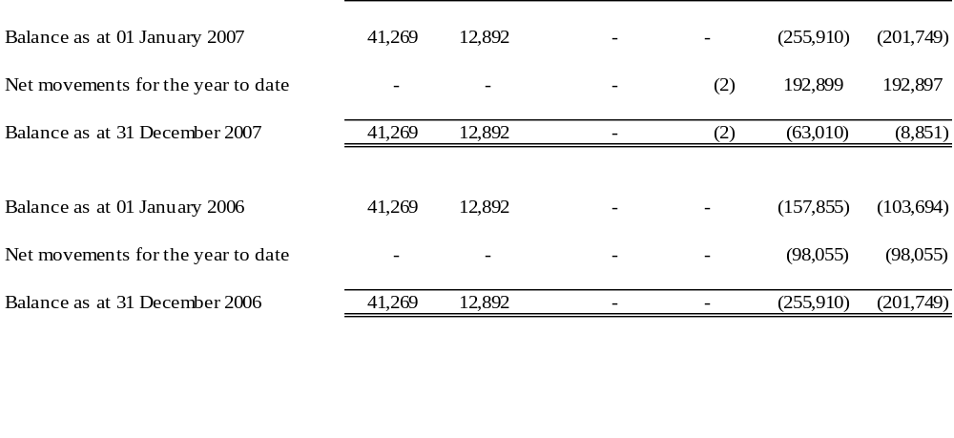

The condensed consolidated statement of changes in equity should be read in conjunction with the Annual Financial Report for the year ended 31 December 2006.

EXPLANATORY NOTES
1. BASIS OF PREPARATION
The interim financial statements are unaudited and have been prepared in accordance with the requirements of Financial Reporting Standard (FRS) 134, Interim Financial Reporting issued by the Malaysian Accounting Standards Board (MASB) and paragraph 9.22 and Appendix 9B of the Listing Requirements of Bursa Malaysia Securities Berhad.
The interim financial statements should be read in conjunction with the audited financial statements of the Group for the year ended 31 December 2006.
2. CHANGE IN ACCOUNTING POLICIES
The accounting policies and methods of computation adopted by the Group in these quarterly financial statements are consistent with those adopted in the most recent annual audited financial statements for the year ended 31 December 2006, except that the Group has adopted the new/revised standards mandatory for annual periods beginning on or after 1 January 2007, as follows:

FRS 117 | Leases
FRS 119₂₀₀₄ (Revised) | Employee Benefits – Actuarial Gains and Losses, Group Plans and Disclosures
FRS 124 | Related Party Disclosures

The adoption of the above FRSs does not have any significant financial impact on the Group.
3. AUDIT REPORT OF PRECEDING FINANCIAL STATEMENT
The annual financial statements of the Group for the year ended 31 December 2006 were reported with qualification in respect to the ability of the Group and the Company to be able to continue as going concerns.
The Company together with a team of professionals had on 23 January 2007 submitted its Proposed Corporate Restructuring Exercise (“PCRE”) to the Securities Commission (“SC”). The SC had vide their letter dated 30 April 2007 approved the said PCRE (details to which are further explained in Note 10 below).
The Company is presently taking the necessary steps to implement the aforesaid PCRE.
4. EXCEPTIONAL ITEMS

The items affecting assets, liabilities, equity, net income or cashflows that are unusual because of their nature, size or incidence have been included in the interim financial statements. Kindly refer to note 17 for further details.
5. CHANGES IN ESTIMATES
There were no changes in estimates of amounts that give a material effect for the current quarter.
6. TAXATION
Taxation for the current period is as follows:
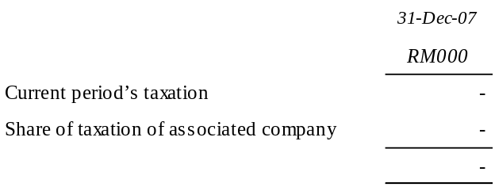
No taxation has been provided in the current year to date.
7. SALE OF UNQUOTED INVESTMENTS / PROPERTIES

There has been no disposal of any unquoted securities or properties during the current quarter.
8. PURCHASE OR DISPOSAL OF QUOTED SECURITIES

There has been no purchase or disposal of any quoted securities during the current quarter.
9. CHANGES IN GROUP COMPOSITION
Under the aforementioned PCRE the Company was to acquire the entire shareholding in Ark M&E Sdn Bhd (“ArkM”) and Ark Development Sdn Bhd (“ArkD”). Please refer to Note 10 below for further details. As a consequence, ArkM’s and ArkD’s financial results and balance sheet have been included in the Group’s financial results and balance sheet accordingly.
10. CORPORATE PROPOSALS
The Company had on 23 January 2007 submitted to the SC its PCRE entailing the following:-

Proposed Capital Reduction;
Proposed Acquisitions;
Proposed Debt Restructuring;
Proposed Liquidation;
Proposed Rights Issue with Warrants; and
Proposed Placement with Warrants
The SC had vide their letter dated 30 April 2007 approved the aforementioned PCRE. In this regard, the Company has commenced the implementation process of the abovementioned PCRE via liquidating its subsidiaries that was not part of the Group moving forward. As such, Lankhorst Pancabumi Contractors Sdn. Bhd (“LPC”) and Cardon (M) Sdn Bhd (“Cardon”) were liquidated on 15 May 2007 and 19 July 2007 respectively. The creditors of Cardon had also on 19 July 2007 sanctioned the disposal of its wholly owned subsidiary, Ark Construction Sdn Bhd (“ArkC”) to the Company on 19 July 2007. Subsequently, the creditors of LPC had sanctioned the disposal of ArkM and ArkD to the Company on 23 October 2007.
The Company, ArkM, ArkD and Ark Hartanah Sdn Bhd had on 7 December 2007 obtained a further extension of the Restraining Order pursuant to Section 176 of the Companies Act 1965 from the High Court of Malaya, Kuala Lumpur by an additional 97 days i.e., to expire on 31 March 2008.
In addition, the Company and its affected subsidiaries have also obtained the required majority pursuant to Section 176 of the Companies Act 1965 at their earlier held respective Court Convened Meetings (“CCM”). These CCM were held in line with the Proposed Debt Restructuring Scheme (“PDRS”) which forms part of the said PCRE.
Pursuant to the CCM and Extraordinary General Meeting (“EGM”) of the Company that were held on 28 February 2008, the shareholders of the Company had approved the PDRS and PCRE during the CCM and EGM respectively. The above meetings were conducted in line with the PCRE which was approved by the SC on 30 April 2007.
11. ISSUANCE OF EQUITY SECURITIES AND REPAYMENT OF DEBT SECURITIES, SHARE BUY-BACKS, SHARE CANCELLATIONS, SHARES HELD AS TREASURY SHARES AND RESALE OF TREASURY SHARES
There were no issues of equity securities and repayment of debt securities, share buy-backs, share cancellations, shares held as treasury shares and resale of treasury shares during the current year and quarter.
- GROUP BORROWINGS
All borrowings by the group and corporate guarantees given by the Company, in respect of credit facilities and certain creditors of LPC will be addressed by the Company pursuant to the PDRS.
13. OFF-BALANCE SHEET FINANCIAL INSTRUMENTS
There are no off-balance sheet financial instruments in issue.
14. CHANGES IN MATERIAL LITIGATION
There are no other changes in material litigation involving the remaining companies of the Group.
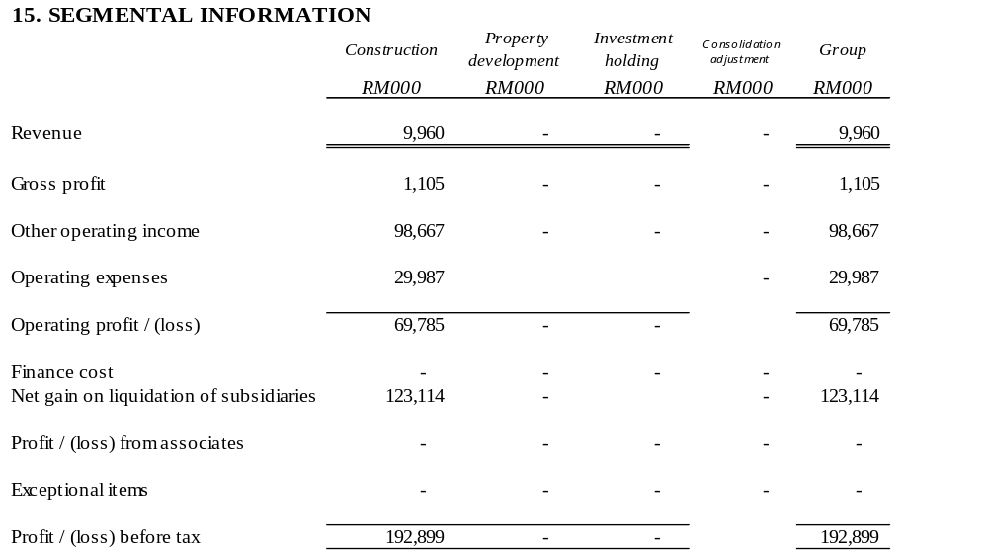
16. REVIEW OF PERFORMANCE

The Group’s revenue reduced by 39% for the fourth quarter of 2007 as compared to the corresponding quarter in 2006. However, the Group recorded a profit before tax of RM78.9 million in the current quarter as compared to a loss of RM31.7 million in the same quarter of the preceding year.
The decrease in revenues for the current quarter against the corresponding 2006 quarter was due to completion of certain projects during that quarter. The Group has since embarked on its new projects during the quarter under review.
The significant increase in profit before tax as compared to a loss in the preceding year corresponding period is due to the effects of the write backs of the debts pursuant to the PDRS and the deconsolidation of LPC & Cardon.
17. EXPLANATORY NOTE ON MATERIAL CHANGE
The Group registered a profit before tax of RM78.9 million in the current quarter as compared to a loss before tax of RM31.7 million in the preceding year corresponding quarter. The significant increase in profit before tax is mainly attributable to the effects of deconsolidating Cardon & LPC and write back of the debts pursuant to the PDRS.
18. MATERIAL EVENTS SUBSEQUENT TO BALANCE SHEET DATE
Pursuant to the CCM and EGM of the Company that were held on 28 February 2008, the shareholders of the Company had approved the PDRS and PCRE during the CCM and EGM respectively. The above meetings were conducted in line with the PCRE which was approved by the SC on 30 April 2007.
19. SEASONAL AND CYCLICAL FACTORS
There are no significant variations to the level of profit due to seasonal or cyclical effects of operations.
20. EXPLANATORY NOTE ON PROFIT FORECAST/GUARANTEE
No profit forecast / guarantee have been given by the company.
21. PROSPECTS
In tandem with the expected improvement in the economy, the Directors believe that the Group’s performance will progressively improve. The Group will continue with its ongoing efforts to implement the PCRE and improve operational efficiency in order to achieve better results.
Further significant contributions to revenue from these projects are expected to come in the coming quarters.
22. DIVIDENDS
No interim or final dividend has been declared or recommended.

